
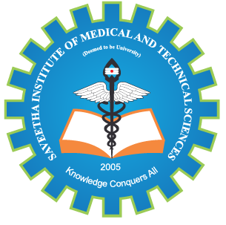
SIMATS ENGINEERING

Saveetha Institute of Medical and Technical Sciences
Chennai- 602105

Student Name: K V Sai Kiran Reg no :192465056
Course Code: ITA1410 Slot: A
Course Name: Ethical hacking for network security
Course Faculty: Dr Padmakala S , Dr Bhuvaneswari M
Project Title: USB MALWARE DETECTION AND PREVENTION SYSTEM
Module Photographs: (photographs –Module Photo, student contribution module work in the project and presentation image)
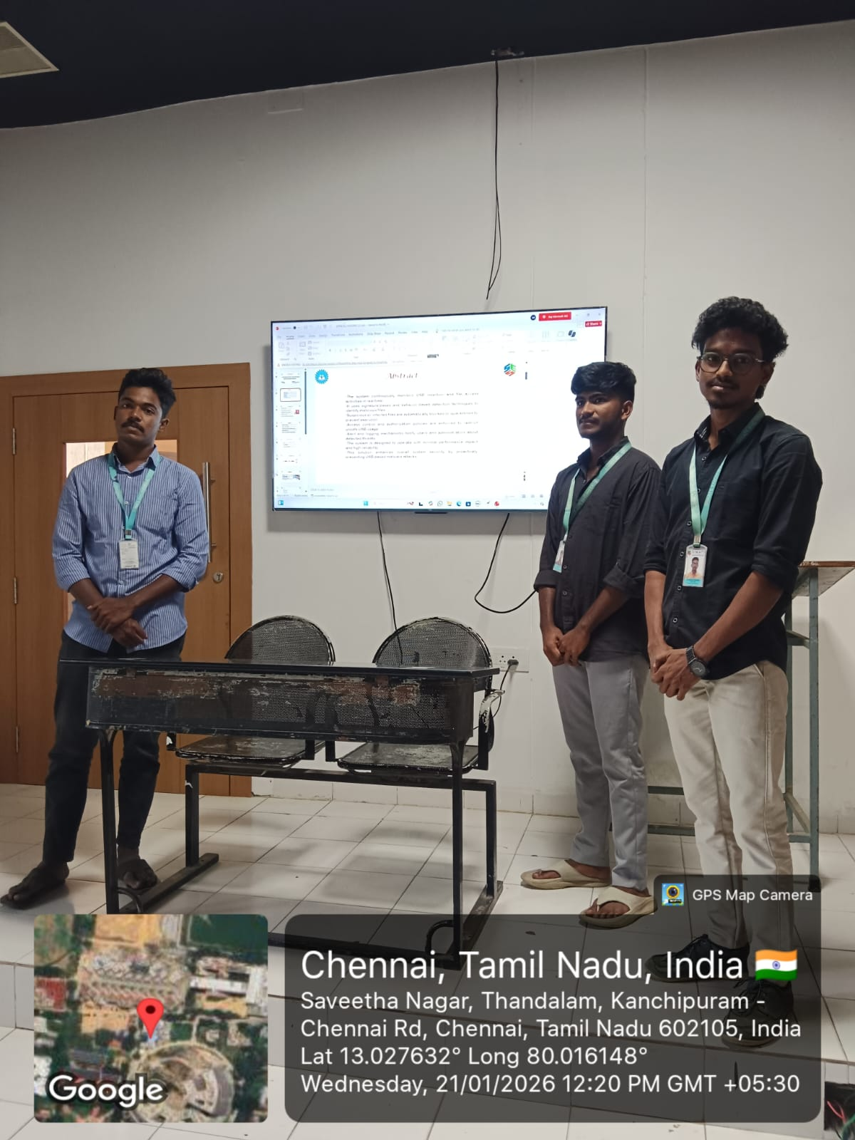
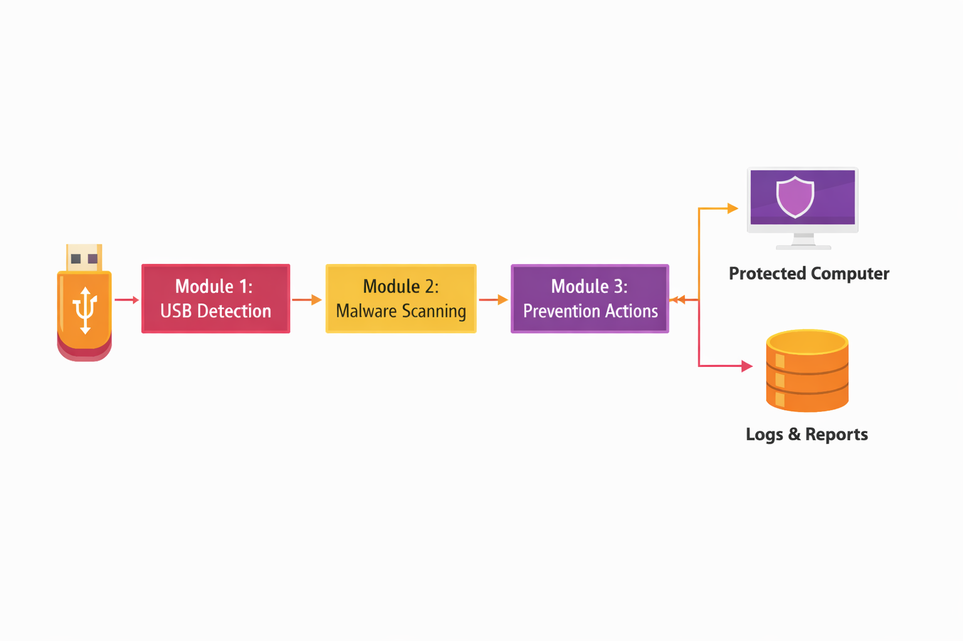
Project Description: (here you write what you did in this project (contribution) including Model Description
The USB Malware Detection and Prevention System is designed to protect computer systems from malicious software introduced through USB storage devices. The system continuously monitors USB insertion events and automatically scans connected devices to detect potential threats using signature-based and behavior-based detection techniques. When a malicious file is identified, the system prevents its execution by blocking, quarantining, or removing the file, thereby stopping the spread of malware such as viruses, worms, trojans, and ransomware.

Student Signature Guide Signature

